**Data Reporting and Analysis with T-SQL**

**(Submitted by – VIKRAM SINGH)**

***Project :* Product sales performance analysis using T-SQL**

***About the project:***Analysis of sales of various products by customers demographics and product categories for Adventure Works Cycles using T-SQL programming on Azure Data Studio.

***Aim:*** Using T-SQL programming to summarize the sales of Adventure Works Cycles with respect to product characteristics, promotion cost and customer demographics.

***Questions:***

1. Establish connection with SQL servers

Ans :- Steps to establish connection with sql servers are:-

* + Connect to a SQL Server instance.
  + Create a database.
  + Create a table in your new database.
  + Insert rows into your new table.
  + Query the new table and view the results.
  + Use the query window table to verify your connection properties.

1. Generate reports to containing details of the company’s customers to support sales campaign
   1. Retrieve customer details

Familiarize yourself with the Customer table by writing a Transact-SQL query that retrieves all columns for all customers.

Ans:-

SELECT *  FROM [SalesLT].[Customer]

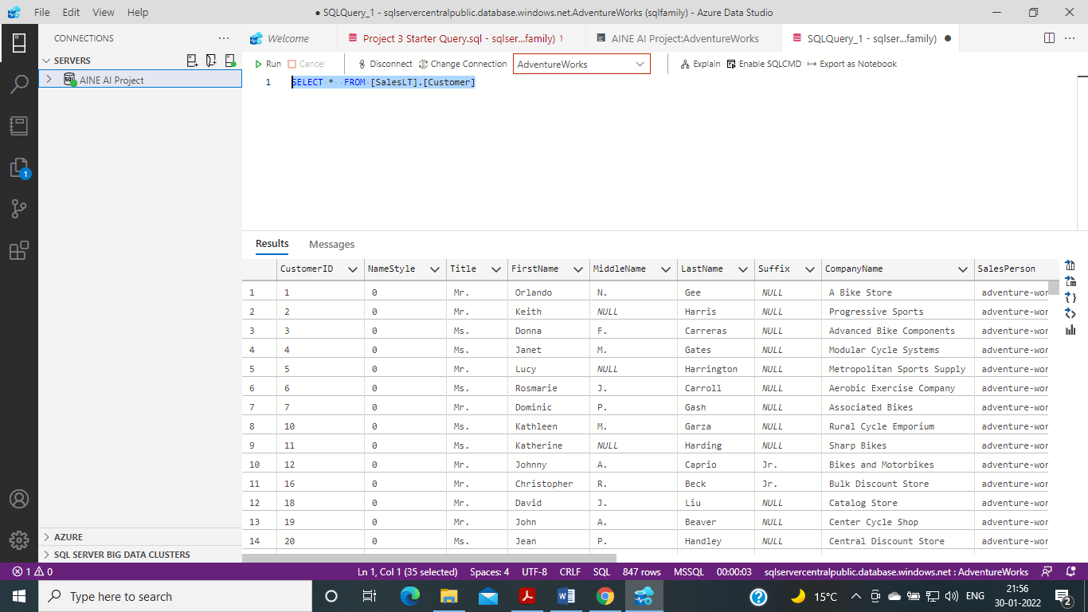

1. Retrieve customer name data

Create a list of all customer contact names that includes the title, first name, middle name (if any), last name, and suffix (if any) of all customers.

Ans:-

SELECT

      [Title]

      ,[FirstName]

      ,[MiddleName]

      ,[LastName]

      ,[Suffix]

  FROM [SalesLT].[Customer]

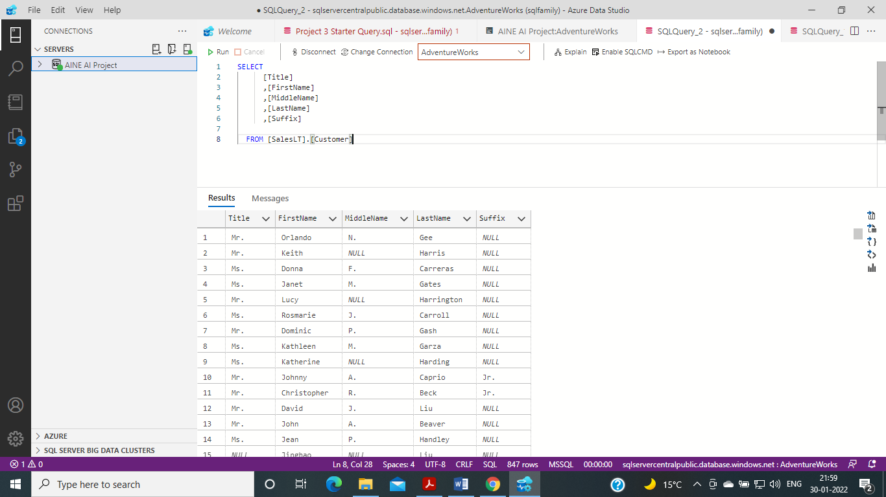

1. Retrieve customer names and phone numbers

Each customer has an assigned salesperson. You must write a query to create a call sheet that lists:

• The salesperson

• A column named CustomerName that displays how the customer contact should be greeted (for example, “Mr Smith”)

• The customer’s phone number.

Ans:-

SELECT

      [Title]

      ,[FirstName]

      ,[SalesPerson]

      ,[Phone]

  FROM [SalesLT].[Customer]

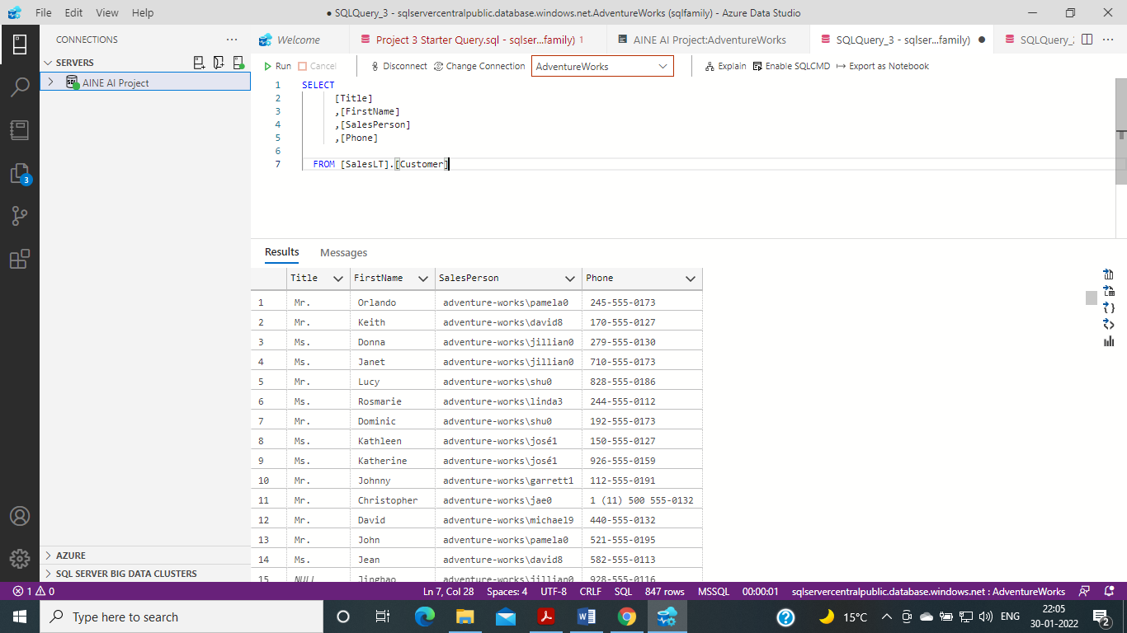

1. Concatenating columns to create reports from same tables
   1. Retrieve a list of customer companies

You have been asked to provide a list of all customer companies in the format : - for example, 78: Preferred Bikes.

Ans:-

SELECT CAST(CustomerID AS varchar) + ': ' + CompanyName AS CustomerCompany

FROM SalesLT.Customer;

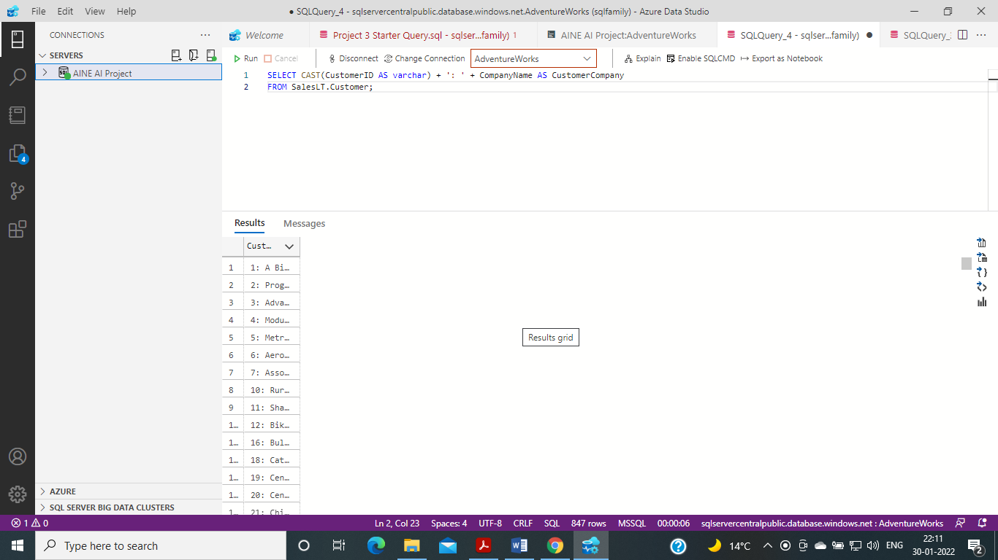

1. Retrieve a list of sales order revisions

The SalesLT.SalesOrderHeader table contains records of sales orders. You have been asked to retrieve data for a report that shows:

• The sales order number and revision number in the format () – for example SO71774 (2).

• The order date was converted to ANSI standard format (yyyy.mm.dd – for example 2015.01.31).

Ans:-

SELECT SalesOrderNumber + ' (' + STR(RevisionNumber, 1) + ')' AS OrderRevision,

     CONVERT(nvarchar(30), OrderDate, 102) AS OrderDate

FROM SalesLT.SalesOrderHeader;

